

**Explanation:-**

I have displayed the file named **“test.txt”** from HDFS using **cat** command.

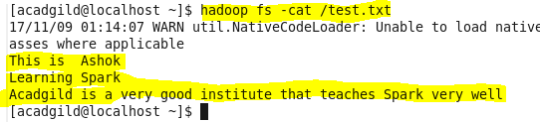

I have loaded the file named **“test.txt”** from HDFS and it is assigned to **“a”** of type val.



Here each line will be taken as one element in Array as you can see in the below screenshot



Now **count** will create the no of the elements in Array created for a.collect().You can see that we got the required output as 3.





**Explanation:-**

I have loaded the file named **“test.txt”** from HDFS using **cat** command.



Here each line will be taken as one element in Array as you can see in the below screenshot



Here for each element x in Array of a, it will be splitted by “ “ as seperator. Now once splitted **flapMap** transformation function will take the each splitted word using the separator “ “ as token. **flatMap** Transformation function in spark is similar to string tokenizer function in Java.



With the help of separator “ “, we have spliited and taken each element in the Array as tokens using FlatMap transformation function. Now each word in textfile “test.txt” is stored in Array ”b”.



Now using count(), we can count the no of elements in the Array. Actually we are counting the no of words in the file “test.txt” and output is 16.





**Explanation:-**

I have displayed the file named **“sample.txt”** from HDFS using **cat** command.

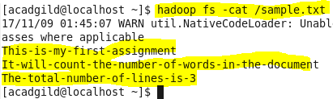

I have loaded the file named **“test.txt”** from HDFS using **cat** command.



Here each line will be taken as one element in Array as you can see in the below screenshot



Here for each element x in Array of a, it will be splitted by “-“ as seperator. Now once splitted **flapMap** transformation function will take the each splitted word using the separator “-“ as token. **flatMap** Transformation function in spark is similar to string tokenizer function in Java.



With the help of separator “ -“, we have splitted and taken each element in the Array as tokens using FlatMap transformation function. Now each word in textfile “sample.txt” is stored in Array ”b”.



Now using count(), we can count the no of elements in the Array. Actually we are counting the no of words in the file “sample.txt” and output is 22.

